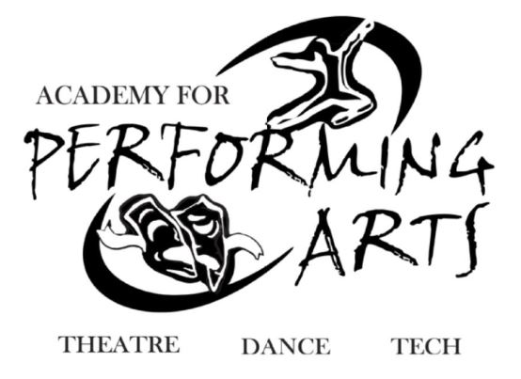 Announcing UCAPA-PTSO
Union County Academy for Performing Arts is pleased to announce the sale of UCAPA “Spirit Wear” clothing featuring the school logo. Place orders at https://www.ucapaptso.com/shopapa
SpiritWear!
Description | Picture | Size  (Please Circle your size) | Price | Total
Zipper Hooded Sweatshirt |  | S/M/L/XL/2XL/3XL | 40.00
Pullover Hooded Sweatshirt |  | S/M/L/XL/2XL/3XL | 35.00
Fitted, Bella T-shirt |  | S/M/L/XL/2XL | 20.00
Regular T-shirt |  | S/M/L/XL/2XL/3XL | 20.00
Flannel Pants with Logo | 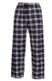 | S/M/L/XL/2XL | 35.00
Open bottom Sweatpants |  | S/M/L/XL/2XL/3XL | 30.00
Elastic bottom Sweatpants | 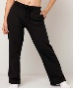 | YXL,S/M/L/XL/2XL/3XL | 30.00
Car Magnet | 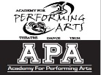 | One size | 10.00
Drawstring Bag |  | One size | 10.00
Pullover Crewneck Sweatshirt |  | XL | 25.00
 |  |  | Total

Questions Contact: Kara Rever email: qkara@aol.com
If you prefer to order by mail
Make checks payable to: PTSO of the UCAPA and mail this form & your check to the
PTSO of the UCAPA P.O. Box 273 Fanwood, NJ 07023

Student name: ____________________________________ Graduating Year: _____________________________________

Amount Enclosed: ________ Check Number: ______ Parent/Guardian’s name: ___________________________________
Phone number or e-mail in case we have questions about your order: Phone #: ___________________________________

(Please PRINT CLEARLY) Email Address: ___________________________________________________________________

(Prices valid for the 22-23 school year)

