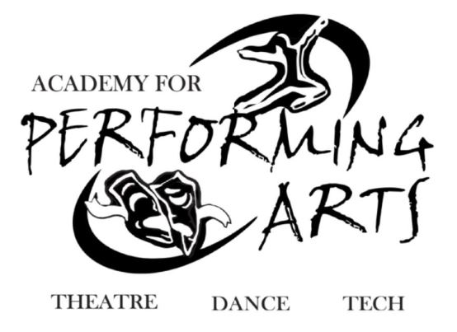
SpiritWear!
Announcing UCAPA-PTSO
Union County Academy for Performing Arts is pleased to announce the sale of UCAPA “Spirit Wear” clothing featuring the school logo. All students should mail orders to the spirit wear coordinator. Please note: payment in full must be included with this order form and all checks should be made payable to “UCAPA-PTSO”.
Please staple your check to this form
Description | Picture | Size  (Please Circle your size) | Price | Total
Zipper Hooded Sweatshirt |  | S/M/L/XL/2XL/3XL | 35.00
Pullover Hooded Sweatshirt |  | S/M/L/XL/2XL/3XL | 30.00
Fitted, Bella T-shirt |  | S/M/L/XL/2XL | 18.00
Regular T-shirt | 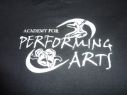 | S/M/L/XL/2XL/3XL | 15.00
Flannel Pants with Logo | 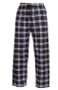 | S/M/L/XL/2XL | 28.00
Open bottom Sweatpants |  | S/M/L/XL/2XL/3XL | 10.00
Elastic bottom Sweatpants |  | S/M/L/XL/2XL/3XL | 20.00
Nylon Gym Bag | 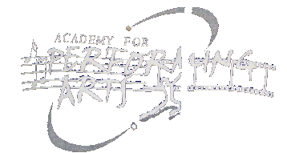 | One size | 10.00
Car Magnet | 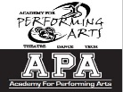 | One size | 12.00
 |  |  | Total

Questions Contact: Jennie Hernandez: hernandez4kidz@aol.com T: 908 279-3766

Make checks payable to: UCAPA-PTSO and send to the UC APA PTSO P.O. Box 273 Fanwood, NJ 07023

Student name: ____________________________________ Graduating Year: _____________________________________

Amount Enclosed: ________ Check Number: ______ Parent/Guardian’s name: ___________________________________
Phone number or e-mail in case we have questions about your order: Phone #: ___________________________________

(Please PRINT CLEARLY) Email Address: ___________________________________________________________________

Rec’d by: ____________________________________ Amount: __________________ Date: ______________________

